**(Reap logo)  
Cohort 14 has commenced!**

After a rigorous selection process, we take great pride in introducing the five exceptional startups that have earned their spot in Cohort 14. These innovative startups represent a diverse range of focus areas, spanning from robotics to alternative materials to hospitality.

**(All 5 startup logos)**

It brings us immense joy to announce the successful onboarding of our latest cohort of groundbreaking PropTech startups. During an intensive two-day induction program, we warmly welcomed them into the vibrant REAP community, offering valuable insights into our program and fostering a sense of camaraderie among our newest members. The induction program culminated in an unforgettable evening of networking and socialising, where our new cohort had the opportunity to connect with seasoned industry leaders and like-minded entrepreneurs. As we embark on this exciting journey together, we couldn't be more thrilled to have these exceptional startups on board, and we are committed to supporting them wholeheartedly in their pursuit of innovation and growth.

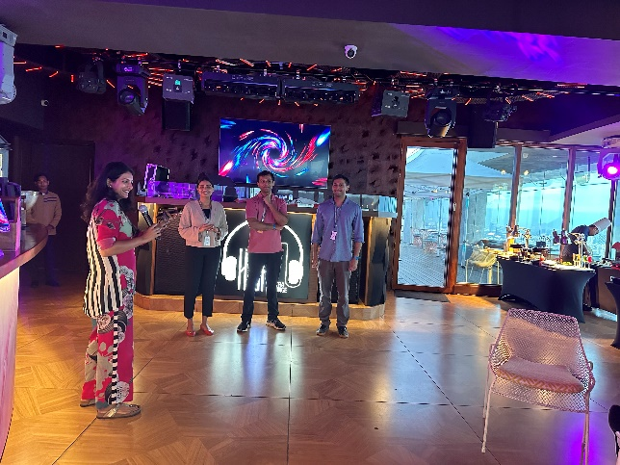

**Reboot@REAP (Logo)**

At Reboot@REAP, we achieved a significant milestone in the history of REAP by successfully bringing together all our portfolio companies from across the country. This momentous occasion allowed us to inspire one another and collaboratively brainstorm innovative ways to propel the PropTech ecosystem at scale. The event served as an exceptional platform for accomplished founders and co-founders to connect, collaborate, and share their invaluable experiences.

We couldn't have been happier to witness the vibrant synergy as our startups gathered under one roof, exchanging ideas and forging new partnerships that will undoubtedly set the stage for groundbreaking innovations. The opportunity to reunite with our incredible founders and witness their remarkable growth was truly a pleasure.

As an organisation, we take immense pride in the thriving startup community we've cultivated. Reboot@REAP has set a precedent for future gatherings, and we eagerly anticipate even more impactful collaborations and breakthroughs in the days to come.

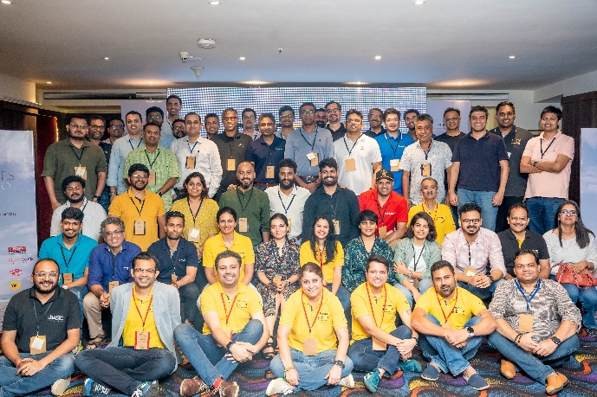 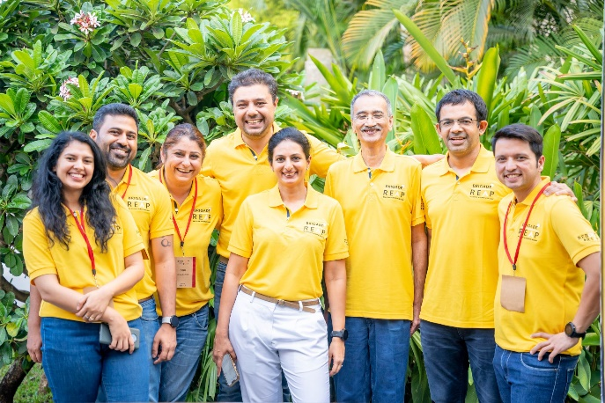

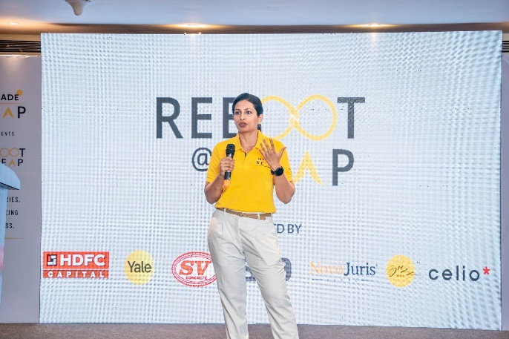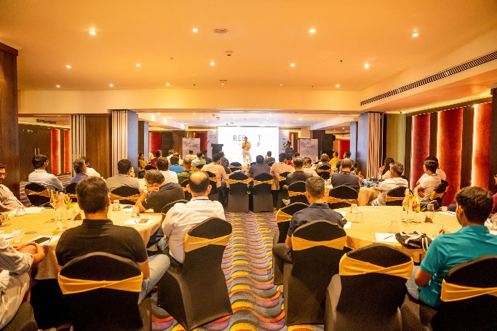

**Awards and Recognition**

* Angirus® IND (https://www.angirusind.com/) from our 9th cohort has been prominently featured on the World Economic Forum.

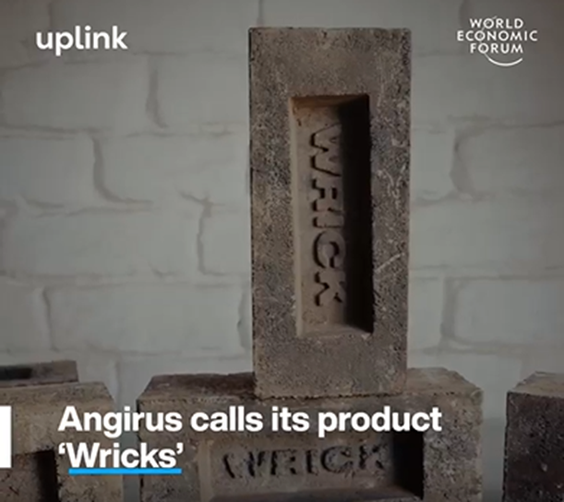

* Two of our portfolio startups, Clairco (https://www.clairco.in/) and WEGoT (https://www.wegot.in/), specialising in Utility Solutions, have successfully made it to the prestigious list of 43 #cleantech startups compiled by Inc42 Media.

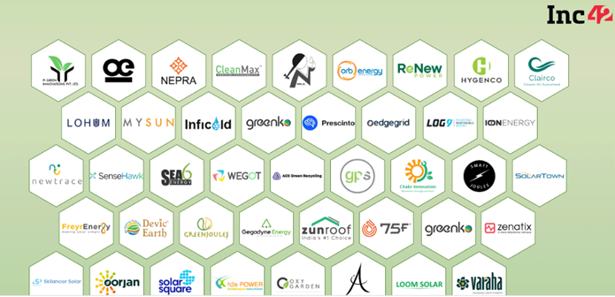

* Clairco (<https://www.clairco.in/>), a company from our 4th Cohort, has been selected as one of the three winners for the prestigious ALDAR ScaleUp challenge in Dubai.

